Classic Cases: Mekach Ta'ut, Get and Annulment
Rachel Levmore, PhD

Abstract
When examining the possibility of annulment of kiddushin in the case of the classic agunah or in the case of get-refusal – the modern-day agunah –, the approach of the contemporary poskim can be discerned through careful analysis of three distinct cases brought before the Israeli Rabbinical Court in Jerusalem.1
We will examine three cases and analyze the differing results:
- A truly classic mekach ta'ut in which an unforgettable ruling was issued—but not of annulment.
- A classic get followed by a claim of mekach ta'ut.
- A classic agunah with husband disappearance in which the marriage was dissolved.

Brief Case Studies
Classic Mekach Ta'ut
In a case that began in the Jerusalem Beit Din Rabbani's "Agunah panel" in 1995 and which lasted until 2001, it initially appeared that the dayanim responded in the best way possible—quickly and sternly, doing everything they could possibly think of. Indeed that was the case until the very end where the dayanim were so creative they managed to ignore the compelling case of mekach ta'ut which was claimed and proven in complete accordance with halakha,² and chose to resort to unorthodox methods (in both meanings of the word) in order to arrange a get – thus avoiding the necessity for dealing with the petition and proven claim of mekach ta'ut.

1
In all three of the cases, I was involved as the to'enet rabbanit which neutralizes the factor of varying involvement of personas.
2
Of particular relevance to this case is the ruling from תשי"ז by the three Rabbinical Court Judges in the Jerusalem
.הרב אברהם שפירא ,מנחת אברהם, חלק ב' סימן י', brought in הרב בנציון עבודי, הרב אברהם שפירא, הרב יוסף כהן :Rabbinical Court The conclusion is cited here:
ומכל הדין נראה שיש מקום לצדד דהוי מקח טעות ואינה זקוקה לגט פיטורין גם מדרבנן. אמנם הנידון דידן חמור מאד איסור דאשת איש ולא מצאנו כמעט בספרי הפוסקים שידונו על ביטול קידושין כה"ד ועיין בספר בית אב להגרא"א יודלביץ שהקיל בזה והביא שםעל הוראה כזו מדודו הגאון מקוברין בעל ניר על הירושלמי וכמדומה שכוונתו על העגונה מעיר דווין שגדולי הדור שעבר דנו בה בספריהם והביאו שם את דברי הגאון הנ"ל שדן להתירה משום ביטול קידושין שהיה נכפה לפני הנישואין והנה שלשת הגאונים הגדולים הגרי"א מקובנה והגי"ר ממינסק והגרצ"ה מבריסק דחו את דבריו והחליטו שאין להזקק משום כך לבטל הנישואין והדבר יצא שם לקולא מצד אחר שהיתה שאלה של הכרת יבם שמת עיי"ש. אמנם שם היתה הבעיא של מום דנכפה והיתה גם בעיא של מום שבגלוי ונידון מום דידן חמור הרבה יותר ממום זה כמובן מאליו וכנ"ל. ומחמת הנימוקים דלעיל יש לצדד להתירה כנ"ל .אמנם מפני חומר הענין לא תנתן החלטה להתיר את האשה אלא בתנאי שיסכים מרן הגאון רצ"פ פראנק שליט"א אב"ד ירושלים בהיתרא של האשה.
התוספת של הרב צבי פסח פרנק: "עברתי על התשובה והנני מצטרף לשריותא דאתתא דא ויפה הורו להתירה בלי חשש ושריא היא למינסב לכל גבר כדמו"י וע"ז באה"ח צבי פסח פראנק".

Get Followed by a Claim of Mekach Ta'ut
Although all the participants in this drama lived in Israel, a sympathetic Beit Din in the Diaspora was willing to deal with a case of a woman who had been divorced in Israel and then remarried. After the wedding it became apparent that the second husband was not capable of engaging in intimate relations, although he had assured the woman that he was capable of such when she inquired (due to his age) prior to her agreeing to the marriage. They attempted, unsuccessfully, to find a medical solution for nine months. After that the second husband gave the woman a get. The question then arose if the woman and her first husband could remarry, since they had a number of children together – could he be מחזיר את גרושתו despite the fact that she had married after their divorce? Could the second marriage be annulled on the basis of mekach ta'ut, thus freeing the woman to return to her first husband?
The Beit Din in the Diaspora turned with the question to a member of the High Rabbinical Court in
Jerusalem, HaRav Tzion Buaron. In 2009 he issued the following ruling, after a lengthy discussion
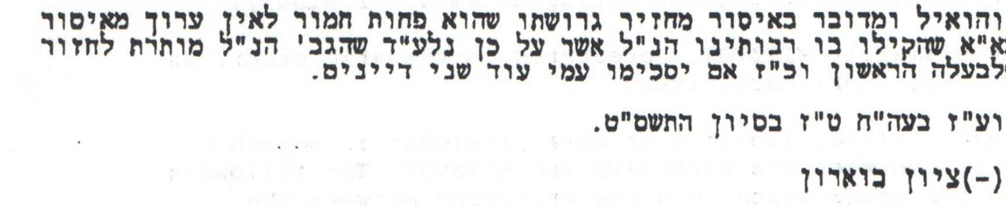
HaRav Buaron then wrote to HaRav Ovadiah Yosef asking for his opinion, and HaRav Ovadiah Yosef agreed with the ruling.
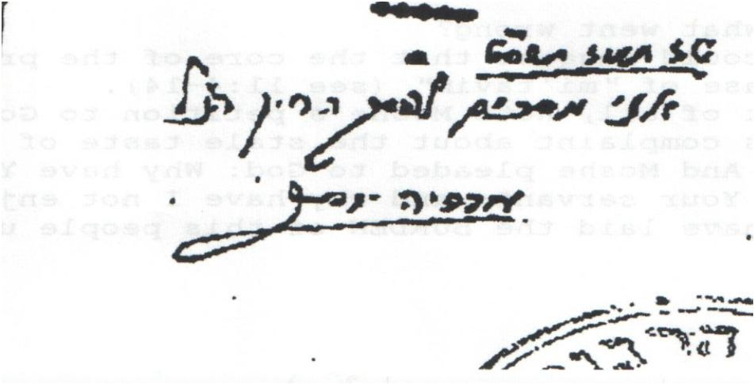
The ruling of annulment due to mekach ta'ut was issued; the woman and her first husband did indeed remarry in the act of המחזיר את גרושתו.
A Classic Agunah -- Husband Disappearance
In a marriage between an American woman and an Israeli man living in the US, in 1998, where the officiating Orthodox rabbi was the woman's friend, the man became violent and subsequently, literally disappeared. The woman eventually obtained a civil divorce. In 2006 the woman became religious and understood that due to the Orthodox ceremony, she was in need of a get. When she turned to the officiating rabbi, he informed her that one of the witnesses was not a kosher עד. After turning to various American Rabbinic Courts and individual rabbis, a particular court called in the two witnesses for the kiddushin. The officiating rabbi had since passed away but one of the witnesses testified that he himself told the rabbi, when asked to serve as an עד, that he was not a kosher עד since he was not shomer Shabbat and the rabbi replied—that is exactly why I want you serve as an עד – there may be a need to annul the marriage in the future! The rabbi had planted the way out of iggun for this woman since he suspected that the husband would eventually abandon her and any children they would have—which actually came to pass. The second witness corroborated the fact that the first was not shomer Shabbat. The woman came on aliyah and filed for an annulment with the Beti Din Rabbani. Her file was moved to the Directorate of the Rabbinical Courts which employed an investigator in an attempt to find the husband for two years – to no avail. At the same time, the American Beit din submitted all the testimony it had taken from the two witnesses. That, together with a written opinion from an American rabbi that there was no valid act of kiddushin here, brought the Jerusalem Rabbinic Court (Dayanim: HaRav Avraham Sheinfeld, HaRav Eliyahu Aberjell and HaRav Mordechai Toledano) to rule for a Bitul Kiddushin, contingent on the agreement of Chief Rabbi HaRav Amar:
לאחר העיון והשיקול, לדעת הרוב יש להתיר למבקשת להינשא בדמו"י, פרט לכהן. אם יסכים עמנו כב' הראש"ל נשיא ביה"ד הגדול שליט"א.
Indeed, on Nov 6, 2012 HaRav Amar agreed with the majority opinion and the woman was granted an annulment of the marriage.
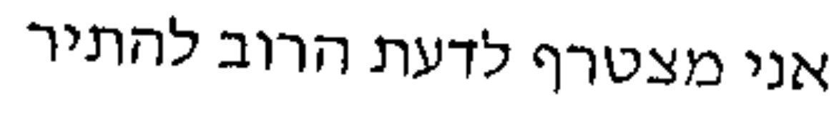

Conclusions
It is indeed possible to present cases to the Beit HaDin HaRabani HaMamlachti in Israel asking for an annulment of the marriage. However, a distinction must be drawn at the outset of the petition as well as in the very essence of the petition.
When presenting the petition, there is a definitive difference between requesting an annulment based on mekach ta'ut or one based upon a technicality invalidating the kiddushin ceremony. The latter, in the case of real husband disappearance and all else having failed, may bring about a ruling of annulment, as was demonstrated by case #3.
Furthermore, the essence, the defining factor of a petition for an annulment based on mekach ta'ut, must be examined in order to understand when it will be successful and when not. The determining factors can be divided into two categories:
- A situation of classic get-refusal where the husband stands before us refusing to give a get and the woman has the legal standing of an אשת איש.
- The question which has arisen is not a question of being מתיר אשת איש, but rather the clarification and possible transgression of a לאו – even if a דאורייתא.
In the latter category of the transgression of a לאו, fall petitions for mekach ta'ut for the purposes of המחזיר את גרושתו, as we saw; or of התרת יבמה from the זיקת ייבום when the Yabbam is incapacitated, has disappeared or the like; or even in the need for התרת ממזר. In these types of cases, the Beit Din will most likely do its utmost to be forthcoming. The Beit Din sees a human tragedy before its eyes which it can alleviate through the use of the tools at its disposal, without incurring serious harm due to its actions if they are mistaken.
However, when a tragic case arises in the former category – that of an אשת איש suffering at the hands of a get-refuser – the Beit Din will steer away from an annulment on the basis of mekach ta'ut. For if it was to rule mistakenly, the results would be disastrous, both on a global scale and in the particular case. A ruling to free an אשת איש which was not reached in complete accordance with the multiple diverse opinions of the poskim throughout the ages would trigger division amongst Am Yisrael in a global sense as well as causing the woman to commit adultery when she finds a second "husband" and cause the bringing of mamzerim into the world, in the particular case. The Beit Din, infused with true יראת שמים, wary of the all-knowing Divine judgment, will err on the side of caution. The suffering of the אשת איש in this world will be considered less significant, when compared to the damage which could be inflicted transcendentally by freeing her in the eyes of Heaven. Thus a petition of an agunah for annulment on the basis of mekach ta'ut will most likely not be granted in contemporary Rabbinical Courts.

Earlier in the ruling it was explained: הואיל והתגרשה לפני כן מבעלה הראשון
This analysis is confirmed by the wording of the קל וחומר reasoning in HaRav Tzion Buaron's ruling cited in case #2 above.

